Forest Stand Improvement for Deer Habitat
A white paper synthesized from two National Deer Association articles and related habitat management references
Source articles:
1. Deer Habitat in a Squirt Bottle part 1: Add Great Deer Habitat by Subtracting https://deerassociation.com/deer-habitat-in-a-squirt-bottle-part-1-add-great-deer-habitat-by-subtracting/
2. Deer Habitat in a Squirt Bottle part 2: Tools, Teams and Techniques https://deerassociation.com/deer-habitat-in-a-squirt-bottle-part-2-tools-teams-and-techniques/

Prepared for private reference use
March 2026
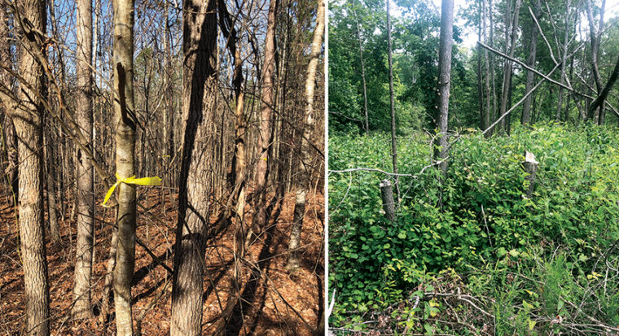
Representative before and after stand response associated with forest stand improvement. Indexed article media from the National Deer Association.

Document note. Because the original webpages were not directly retrievable for full text export in this environment, this white paper is an original, article-based synthesis rather than a verbatim republication. It preserves the articles' main ideas, organization, and available indexed graphics, and supplements inaccessible details with closely related habitat management references.

Executive Summary
The two article series presents forest stand improvement as one of the fastest and most practical ways to improve deer habitat in existing woods. The central idea is simple: habitat often improves when low value or overly competitive woody stems are removed, allowing sunlight to reach the forest floor and release more desirable plants.
Part 1 frames the concept. It treats habitat improvement as a subtractive exercise, where the manager identifies stems that suppress food, cover, or future mast production and removes them so better structure and browse can respond. The indexed media associated with Part 1 highlight mineral stumps, prescribed fire, and stand opening as visible outcomes of this approach.
Part 2 shifts from concept to execution. It emphasizes practical field work, especially the efficiency of combining a saw operator with a second person carrying a squirt bottle for cut stump or hack and squirt treatments. Related habitat guidance corroborates that these methods are effective, budget conscious, and especially useful when the goal is to deaden less desirable stems in place rather than fully remove them.
Taken together, the series makes a strong case that the best deer habitat work in timber is not always additive planting. Often the best first move is to subtract competition, restore light, and then let natural regeneration do the heavy lifting.

Article Series at a Glance
Article | Date | Primary Focus | Takeaway
Part 1: Add Great Deer Habitat by Subtracting | Jan. 20, 2021 | Why removing competition improves habitat | Release desirable vegetation and build structure by opening the canopy and reducing low value stems.
Part 2: Tools, Teams and Techniques | Jan. 27, 2021 | How to execute forest stand improvement efficiently | Use simple tools, a deliberate crew arrangement, and selective herbicide methods to scale the work safely and consistently.

Part 1 Reconstructed Narrative: Add Great Deer Habitat by Subtracting
The first article argues that many woodlots do not lack trees. They lack usable structure and productive understory. When too many stems occupy the same space, sunlight is intercepted high in the canopy, browse is shaded out, and the stand tends to produce less ground-level food and cover for deer. In that setting, adding more plantings is often less effective than first removing the stems that are suppressing the response managers actually want.
Forest stand improvement is therefore presented as habitat triage. The manager walks the stand, identifies crop trees and other desirable species to keep, and then looks for the trees or shrubs that are dominating the space without contributing enough mast, browse, bedding structure, or long term stand value. The objective is not random thinning. It is selective subtraction in service of a stronger understory and a more useful stand.
The series also links stand improvement to visible habitat features. One indexed image from Part 1 focuses on a mineral stump, reinforcing the article's point that cut surfaces, slash, light gaps, and temporary disturbance can all become part of a broader deer habitat response. Another indexed image links the treatment sequence to prescribed fire, suggesting that stand opening is not an isolated act but can be part of a larger habitat management cycle.
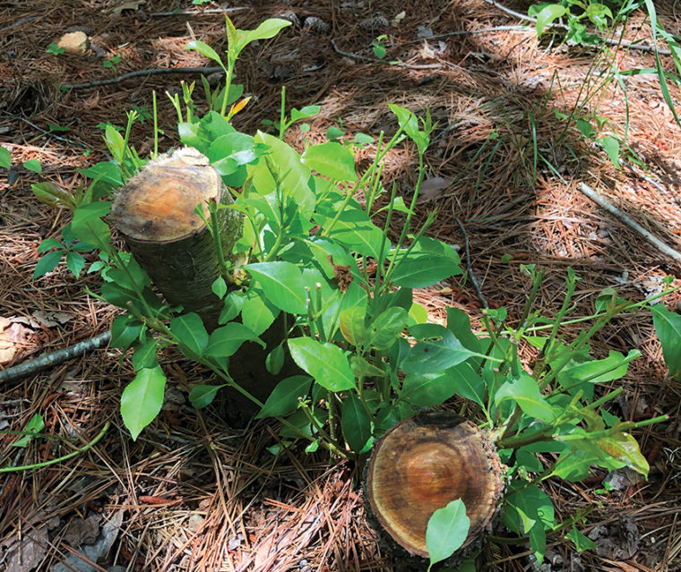
Indexed article media from Part 1 showing a mineral stump outcome associated with subtractive habitat work.
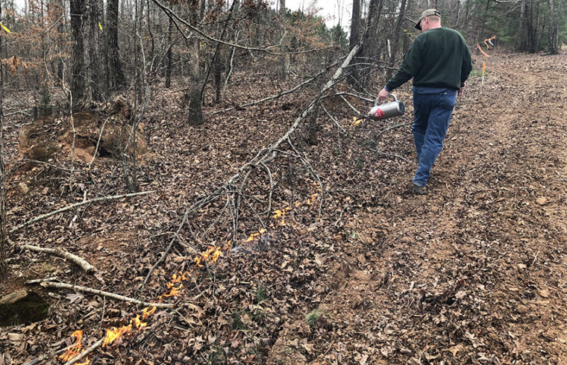
Indexed article media from Part 1 linking forest stand improvement with follow-on fire management.

Why the subtractive approach works
- It restores sunlight to the forest floor, which is usually the first limiting factor in closed canopy woods.
- It releases desirable trees and shrubs from competition, improving future mast, browse, and structural diversity.
- It creates slash, stump sprouts, deadened stems, and other intermediate cover features that can increase bedding and security value.
- It lets natural regeneration respond, which can be cheaper and more site appropriate than trying to plant every improvement.

Original Article (Full)
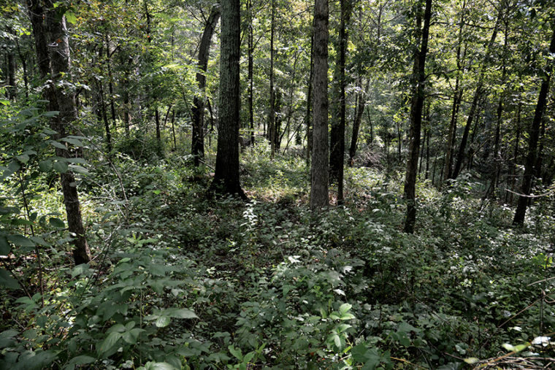
If I ask you to imagine going outside today and creating some great deer habitat, what do you picture? Did you think of something you could add, like seeds or trees you can plant? Let’s be honest, adding things is what most of us think of first. But I’ve come to realize that great deer habitat can also be made by subtracting. Dr. Craig Harper of the University of Tennessee calls it Forest Stand Improvement (FSI).
FSI means removing surplus or non-native trees and shrubs to restore some percentage of the sunlight that fuels an explosion of ground-level forage and cover within a forest, like you see in the photo above, taken in one of Craig’s study areas. Once you learn to identify a few common shrubs and trees that have little wildlife or commercial value, including many that are harmful invasives, you start to see abundant opportunities to create great deer habitat by removing them. Given extra space to grow, the beneficial trees you select to leave will now produce more acorns, nuts, or berries.
The question then becomes how to subtract, and you have lots of options. Working in Georgia under Craig’s guidance, I’ve learned an approach that I’ve found to be extremely useful, effective and easy – girdling or cutting down trees with a chainsaw and spraying the girdle or stump with herbicides that kill it.
Any species of desirable tree can be overabundant. White oaks are valuable and produce high-quality, attractive acorns, but you can have too many of them.
Yes, you can inject herbicides into cuts made with a hatchet or machete and kill trees just as dead – known as the “hack-and-squirt” method. Craig’s girdle-and-spray chainsaw method gives you much more flexibility as you work your way through a stand. With a light chainsaw in your hands, you can:
Girdle a large tree for herbicide injection and kill it standing.
Cut down small trees and shrubs and treat the stumps with herbicide.
Cut down small trees and shrubs with forage value and leave them alive to create “mineral stumps.”
Hinge-cut a small tree to create instant structure.
Applying FSI to any given stand, you will likely encounter the need for all of these options. But only one of them is on the menu when you’re holding a machete. So, here’s a basic guide to FSI with a chainsaw and squirt bottle, including some of the most important lessons I’ve learned from experience. Part 1 covers how to determine your area of work and then how to sort the trees you’ll remove from the trees you’ll leave. Part 2 gets into the finer points of the technique, including herbicide guidance.
Step One, Shut Off Your Saw
Before you read further, know that all of the following assumes you have basic tree-identification skills. Do not begin FSI unless you can identify the most common native mast-producing trees, valuable timber trees, and non-native invasive trees where you hunt – even in winter by bark alone. Buy a good field guide, download an app, or go for a hike with a friend or local forester who can instruct you. You don’t have to know every tree. Even if you only recognize the single most common species in your woods that is a candidate for removal, then you can get to work on that one. But do not kill any tree you cannot identify.
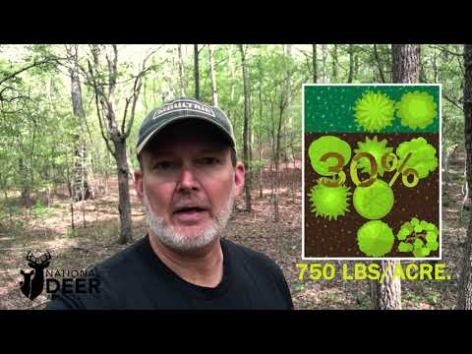
Strategic Patch Selection
Step two is deciding where to start your FSI effort. The vast majority of eastern forests could stand to be improved for deer by adding skylights, and the same is probably true of most of the forested cover where you hunt. Time simply works against you here: Unmanaged forests quickly become shady and unproductive for deer. You’ll be biting off too much at once if you dive in and try to apply FSI to every acre of forest you hunt. Be strategic. Select small stands or patches to tackle each year.
Mark Turner, a graduate student at Auburn University who studied FSI under the direction of Dr. Will Gulsby and Craig, had a great suggestion for me on how to choose your first area: Start with patches that are already surrounded by firebreaks, or those where firebreaks could be easily installed, so you can follow up with prescribed fire easily. Fire will be important for maintaining forage and cover. If you don’t burn at intervals, those patches will eventually revert back to overcrowded, shaded stands of trees.

Select small, manageable patches of forest to start your FSI work. The best patches are those where firebreaks already exist or could be easily installed, since prescribed fire will be important to maintaining quality cover in the future.
Set a patch size that’s reasonable for you given your time, equipment and amount of help available. Work on multiple patches annually if you have the time so you can create a patchwork of different stages of plant regeneration. Locate your patches where you most need cover and forage while taking into consideration your own ease of access for follow-up treatments, deer-stand locations and more.
The Cut-or-Leave Decision
Your patch is selected, and you’re ready to work. Now comes the task of studying tree species, size and proximity and deciding what to do with each of them. Let’s look at some of the choices you can make.
Trees to Kill Standing
These will include trees that are too large to conveniently and safely drop, whether they are invasive tree species you want dead so they stop reproducing or native trees that are prolific reproducers and therefore overabundant in the patch. It’s certainly possible to take the time to make a felling-cut and safely direct large trees to the ground, but then they become obstacles in your work area. Why take the time and risk to drop large trees when you can girdle-and-spray in less than 30 seconds?
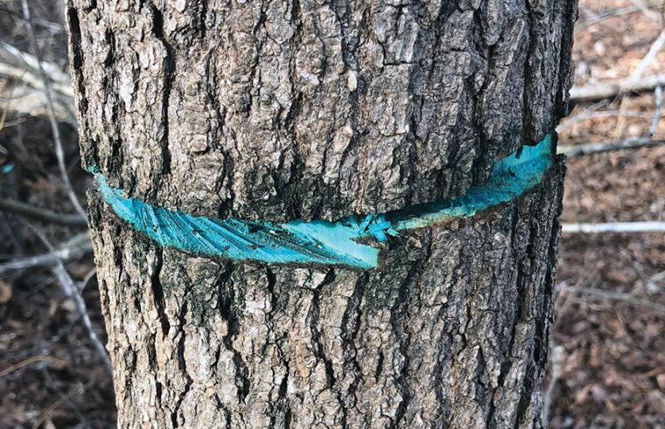
It takes less than a minute to girdle and spray a standing tree, killing it effectively. This is quicker and safer than trying to drop the entire tree, and there are fewer obstacles in your work area.
Trees to Fell and Kill
This includes trees that are too small to be girdled easily but can be dropped with a single saw cut. Often, young stands of abundant saplings of about 1 to 4 inches in diameter present this opportunity to simply cut and stump-spray quickly without girdling. When I’m doing this, I simply cut the tree off at waist-height, because it’s easier and safer than squatting or bending to cut it off near the ground. It’s also easy to spray the stump at this height. The resulting stobs may look unsightly to you, but they’ll rot and fall or disappear in new grass and forb growth soon enough.
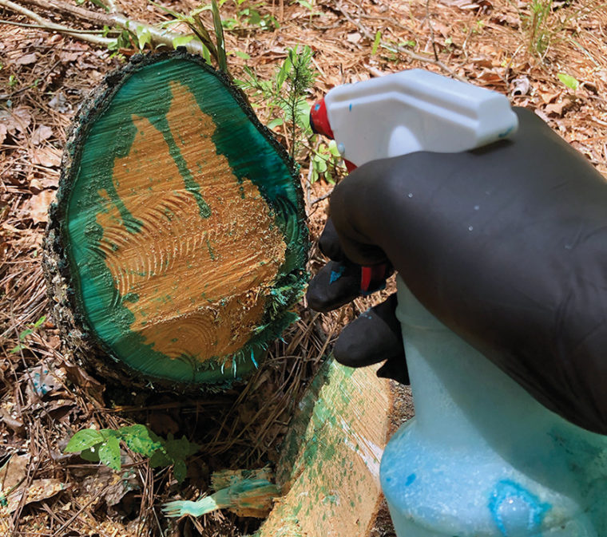
Invasive tree species, like this Callery (Bradford) pear, should be killed by stump spraying if they are small enough to fell. Without herbicide treatment, this stump would sprout and regrow.
In Georgia, we’ve done a lot of work daylighting the shoulders of woods roads and food plot openings. We girdle-and-sprayed a lot of trees in these zones, and guess what happened? After dying, they eventually started falling across the roads or into the openings. This required multiple additional rounds of effort with a chainsaw to clean them out of the roads or plots as they fell intermittently during wind storms. So, my advice now is, on the edges of roads or food plots, go ahead and use directional felling cuts to drop these trees away from the openings or roads, then spray the stumps. It takes more time to kill the tree, but it’s a one-and-done job.
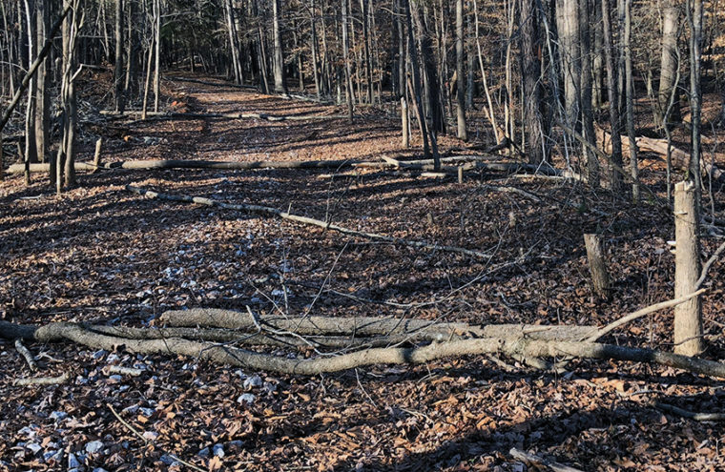
Trees along roads and food plot edges should be dropped with a directional felling cut away from the opening. Otherwise, if you kill them standing, they’ll eventually fall in the road and create more work.
Trees to Fell and Leave Alive
I mentioned “mineral stumps” earlier. This is a term coined by Dr. Marcus Lashley when he was at Mississippi State University for a tree stump that produces sprouts that will be high-preference forage for deer. Marcus found these sprouts are especially high in nutrients and minerals because they are fed by the root system of an entire tree, far better and more attractive forage than the buds and leaves on the branches of the same tree if you hinge-cut it.

Some native species of trees make good “mineral stumps” because deer prefer the stump shoots as forage, and the stumps should not be treated with herbicide. Deer are heavily browsing these black cherry stumps.
Here in Georgia, red maple, blackgum, black cherry, winged elm and tulip poplar are among species that make the most desirable mineral stumps. When we encounter these in small sizes that are easy and safe to cut down, we don’t spray the stumps with herbicide. We leave the tree alive. Deer will kill it eventually by browsing the sprouts.
I don’t try to make mineral stumps out of trees that are too big to quickly and safely drop. I girdle and spray those. The more trees you choose to drop, the more clutter there is in your patch, and the more difficult and risky it is for you to work.
Trees That Present Several Options
Any species of desirable tree can be overabundant. White oaks are valuable and produce high-quality, attractive acorns, but you can have too many of them. Removing surplus white oaks and selecting down to one individual in a given space will allow that tree to outproduce the crowd you eliminated. Research by Craig Harper and his students has shown that giving an oak tree room to grow is the most effective way to increase acorn production.
Beech is another example. Beech trees produce a lot of shade for their typical shape and size, so they are often great candidates for removal. However, they also sporadically produce beech nuts, and you may want to have a few around for that reason. Again, remove the surplus, restore sunlight, and leave a select few individuals to be more productive. The same may go for other native species that have some wildlife benefits you want to maintain. Hickory trees produce nuts that squirrels eat, but that doesn’t mean every hickory is sacred. Mulberries are a fantastic wildlife tree for the fruit, but the stump sprouts are also supremely attractive to deer. I put them to both uses as the situation allows.
By the way, Dr. Craig Harper has just released a new publication on Forest Stand Improvement, including a fantastic reference guide to tree species and their value as deer forage, mast production or hinge-cut suitability. Order the 36-page guide here for $10.
This gives you a good idea of the general approach to applying FSI in your selected patch of woods with a light chainsaw. Next, I’ll cover the girdling technique, the recommended herbicide blend, the two-person team FSI method, and other important pointers.

Part 2 Reconstructed Narrative: Tools, Teams and Techniques
The second article moves from why to how. Search indexing preserves one of its clearest operational points: forest stand improvement often goes much faster with a two person team, one person operating the saw and another applying herbicide with a squirt bottle. That division of labor increases pace, keeps each person focused on a narrower task, and can improve consistency over a long day in the woods.
The article series also clearly centers a practical tool kit. The saw creates the treatment. The squirt bottle makes the treatment durable by preventing resprouting where needed. In related guidance on the same subject, this logic is reflected in two common methods: cut stump treatment for smaller stems that are felled, and hack and squirt treatment for larger stems that are deadened in place.
Part 2 appears to emphasize technique discipline rather than indiscriminate chemical use. The operator must identify the right stem, make the cut properly, place herbicide accurately, and keep the work moving. This keeps the project focused on stand response instead of tree killing for its own sake.
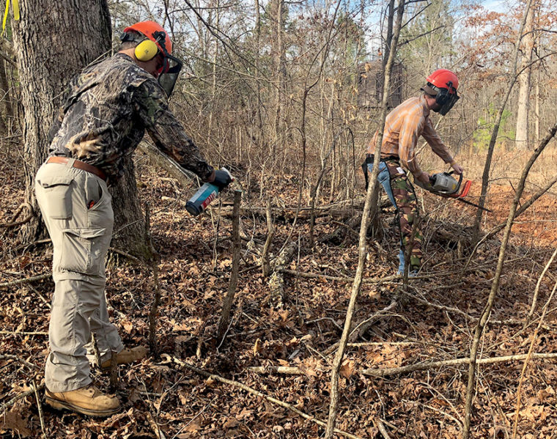
Indexed article media from Part 2 showing the two person workflow often used in forest stand improvement.
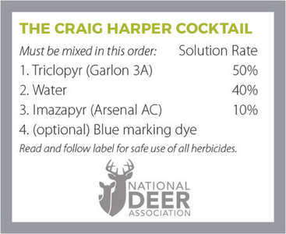
Widely circulated graphic associated with the Craig Harper cocktail referenced in discussion of the article series.

Operational workflow suggested by the series
Step | Description
1. Select | Choose what to keep before choosing what to kill. Favor desirable mast trees, future crop trees, and any stems already contributing to cover or browse.
2. Assign roles | Use a simple crew structure when possible. A saw operator handles cuts; a partner follows with the squirt bottle or other treatment method.
3. Treat deliberately | Use cut stump on stems that are dropped and hack and squirt on stems better left standing. Avoid casual, poorly placed cuts or over application.
4. Evaluate response | Look for light increase, stump sprouting, browse response, and structural change in the first growing season after treatment.

Technique Notes Supported by Related References
The original articles are habitat focused and practical. The table below uses closely related habitat management references to fill in procedural detail that the blocked webpages did not expose directly in this environment.
Technique | Best Use | Advantages | Watch-outs
Cut stump | Small to medium stems you want on the ground | Immediate structural cover, simple visual confirmation, good for forming mineral stumps and slash | Requires prompt treatment on resprouting species; more cutting labor
Hack and squirt | Larger stems better left standing | Less physical removal, creates snags, lower disturbance to soil and surrounding regeneration | Technique matters; avoid heavy sap flow periods and follow label directions carefully
Two person saw and squirt team | Moderate to large projects | Fast pace, specialization, improved rhythm and treatment consistency | Requires good communication, PPE discipline, and safe spacing
Follow-on fire or secondary release | Sites with enough fuel continuity and management capacity | Can expand the understory response after light is restored | Needs planning, timing, and site suitability

Key Lessons for Landowners
- Start with the question, What should remain? The articles are much more about release than destruction.
- Use light as the metric. If the forest floor does not receive enough sunlight, forage and cover response will be limited.
- Be selective. Forest stand improvement is strongest when it is tied to future stand composition, not when it becomes a broad chemical or chainsaw exercise.
- Build repeatable field methods. The two person workflow in Part 2 is effective because it turns habitat work into a disciplined operating process.
- Expect habitat response, not instant perfection. The payoff comes as regeneration, stump sprouts, cover, and desirable tree release accumulate over time.

Original Article (Full)

Removing surplus or non-native trees and shrubs to restore sunlight to the ground, fueling a rebirth of deer forage and cover, is a great way to rapidly improve deer habitat. Dr. Craig Harper of the University of Tennessee calls the technique Forest Stand Improvement (FSI), but it’s not as simple as cranking a chainsaw and dropping the nearest tree. Selecting the right trees to remove and to leave is very important.
In Part 1 of this two-part article, I talked about that selection process. If you didn’t read it yet, start there. I’ll pick up from the end of that article by going into greater details about tools, techniques and other things I’ve learned through experience.
The Ideal Saw
In a word: lightweight. The best chainsaw for this work is one that will not wear you out. You’ll be on the move constantly in your selected FSI patch, girdling large trees and dropping smaller ones, so a smaller, lighter saw designed for pruning and light yard work will be best, because you’ll be able to work longer without needing to rest.
Personally, I use a Stihl MSA 120-C, which is a cordless saw with a rechargeable battery. It weighs only 8.4 pounds. I have worked steadily with it in the woods for over 2½ hours without needing to recharge, and it is excellent for girdling trees. It can do anything I need except felling cuts on very large trees, but that’s rarely necessary in FSI. You can see it in the photo below with the stumps of an invasive Chinese tallow tree I killed.
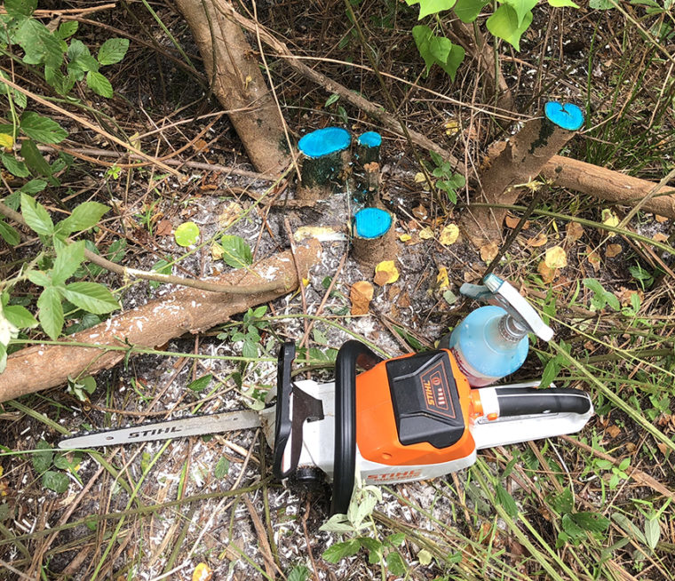
A lightweight saw like this Stihl rechargeable is ideal for FSI because you can work longer in your FSI patch without needing to rest.
The Girdling Technique
Step up to the tree while standing (there’s no need to girdle the tree down low unless it’s forked low, and it’s less safe to run a saw while bending). Holding your saw at a comfortable height, place the top of the bar against the tree. This way, you are cutting with the side of the chain that is moving away from you, which pulls the saw bar into the tree instead of pushing it toward you. It also sprays wood chips away from you.
Holding the saw firmly in both hands, walk around the tree while cutting a shallow groove. You don’t need to push or try to cut deep; the pull of the saw will take care of this. You only need to cut into the cambium layer, just inside the bark. Connect the ends of the girdle to completely sever the cambium layer.
Always make sure you have a clear path completely around the tree before you start cutting. You don’t want to trip, stumble or get tangled in vines and fall with a running chainsaw in your hands. Some trees are crowded among other trees and impossible to girdle easily, and you may have to finesse the work. Take your time, and be careful. Kickback often happens when a running chain contacts another object you aren’t aiming to cut, especially at the nose or end of the saw bar.
Girdling takes a little practice. It doesn’t require a lot of force or throttle unless your saw is extremely dull. After a few tries, you’ll be doing it quickly and easily, but always put safety first. The short video below shows you the girdling technique and just how quickly a two-person team can girdle and treat a single tree (about 15 seconds).

This is How Fast You Can Girdle-and-Spray a Tree for Forest Stand Improvement

Two-Person Teams
You can do FSI alone, but you’ll have to swap constantly between the saw and the squirt bottle. I’ve found FSI goes much faster for a two-person team: one to operate the saw, one to treat trees with the squirt bottle.
With two-person teams, stay in close proximity, because you’ll need to communicate. If you identify and cut a tree to make a mineral stump (see Part 1), you don’t want your partner to spray the stump with herbicide. Since everyone should be using hearing protection around the chainsaw, a signal system is helpful.
If you’re the saw operator, be mindful of your partner’s location when dropping any small trees to the ground. If you’re the squirt-bottle operator, be mindful of wind direction: Don’t drift herbicide mist into your own face or downwind into your partner’s. Of course, don’t spray herbicide in high winds, but there is almost always a slight breeze that may cause some drift.
Both team members should be wearing helmets with face-screens, hearing protection and gloves. Whoever uses the saw should be wearing chainsaw-proof chaps. Whoever uses the squirt bottle should be wearing disposable latex gloves and eyeglasses in addition to a face screen.

Dr. Craig Harper has a new 36-page booklet on FSI, available for $10 from the University of Tennessee. Click the image to order.
How Much Sunlight Do You Need?
As you’re working in your FSI patch, you’ll ask yourself: When do I stop killing trees? Craig said his work indicated 20 to 30% sunlight is necessary to stimulate a significant understory response. Mark Turner of Auburn University documented a 500% increase in forage with a 30% reduction of tree canopy. You’ll get more forage and cover up to about 70 to 80% canopy reduction, and the more space you put between the oaks you leave, the more acorns they’ll produce.
But it may take some time for you to learn to evaluate how much sunlight you’ve restored. I learned one thing when I first tried FSI: When I had the sense I had killed “enough” trees in a certain spot, I was usually wrong. Come leaf-out in spring, trees expand to fill the new space, and limbs now heavy with leaves bend outward to create a much larger shade footprint than you guessed when you were looking at a bare tree in winter. I found myself wishing I’d killed more trees.
Still, don’t overdo it. Cut and kill trees until you feel you have done enough, then review your work in the growing season. You can always return and kill more trees, but it’s a lot harder to put a tree back.

This patch in Georgia was choked and shaded by sweetgums and other overabundant native and invasive trees. One year after FSI, the new sunlight produced an explosion of forage and cover.
Best Time of Year
As far as herbicide effectiveness, the old wisdom is that you shouldn’t use hack-and-squirt in spring when the sap is rising. But according to Craig Harper, this is only true for a few species of trees that are heavy sap producers in spring, such as sugar maples. If you girdle a tree and see sap flow from the cut, this can flush out the herbicide. Otherwise, the herbicide still works on trees in spring.
The best time to do FSI is any time you can. It works year-round.
If you girdle-and-spray trees in winter when they are dormant, most will not green up the following spring. If you do it during the growing season, some will die quickly but most will struggle on through the rest of the year, lose their leaves in fall, and then die.
Working in the comfort of cool weather is nicer than the heat of summer, but it’s easier to identify trees in summer. Otherwise, the best time to do FSI is any time you can. It works year-round. Keep a squirt-bottle handy all year long. At any time you might spot a single invasive tree you want to kill, and you don’t need to plan a special weekend for that.
Best Herbicides
Craig began leading research on killing trees with herbicides in the late 1990s. He soon learned that certain herbicides are ineffective on some tree species, but he didn’t want to carry multiple squirt bottles in the woods. So, he experimented with blends. He discovered what I call the “Craig Harper Cocktail.” Here’s the recipe and instructions.

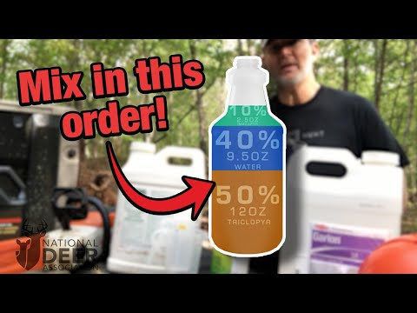
Garlon 3A (triclopyr) is less effective on some species including hickory and sourwood. Arsenal AC (imazapyr) is less effective on locusts, redbud, elm and hophornbeam. When you combine them, their strengths and weaknesses overlap, and you can kill any tree you encounter.
Before you go shopping prices on these herbicides, let me prepare you. The price tags are not cheap, but the good news is that they go a long way. And there are some ways to economize if you need to. Let’s do some math.
Of the two, imazapyr is more expensive. A 2½-gallon jug of Arsenal AC runs around $460, however it makes up only 10% of the recipe – that size jug will make 200 16-oz. spray bottles of Craig’s cocktail.
Triclopyr is around $150 for a 2½-gallon jug, which mixes 40 squirt bottles. To use up an entire jug of Arsenal AC on 200 squirt bottles, you’d need five jugs of Garlon 3A. Grand total, about $1,200. But those 200 squirt-bottles worth of blend will treat a lot of area. Working hard for an entire day with a two-person team, you’d probably use two bottles with approximately $6 worth of herbicide in each, but that can vary with average tree size and density. The bottom line is, your cost per acre treated will be very low, so don’t let the initial investment scare you off.
A 50/50 blend of Garlon 3A and water will still kill a lot of tree species effectively, and if you need to minimize expenses, skip the imazapyr. If you have a lot of hickory or sourwood trees that need to be thinned, though, you’ll have to fell them completely.
In the photos on this page, you’ll notice my herbicide blend is blue, which comes from a dye added separately. Adding blue colorant to your cocktails helps you keep track of what’s been treated, and I recommend using it, especially with two-person teams.
As always, read and follow the label of these and any other herbicides you use.
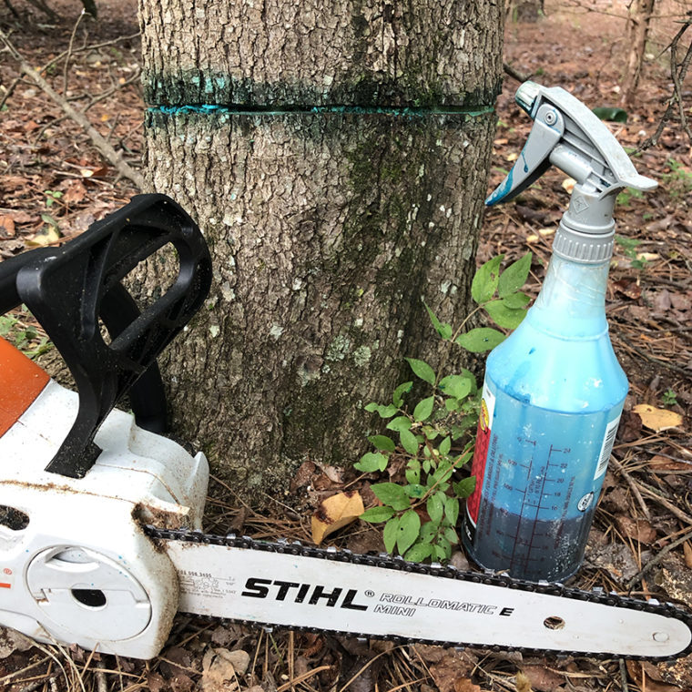
You only need to spray enough herbicide in a girdle to wet the exposed wood. If herbicide is dripping down the tree, reduce the amount applied or adjust the spray/mist nozzle.
Non-Target Effects?
Imazapyr is soil-active, so one of the questions often asked about the Craig Harper Cocktail is whether it kills nearby non-target trees. No – not in the small amounts applied to a girdle or stump. This technique is a surgical strike on individual trees using minuscule doses of chemical.
In his study, Mark Turner applied FSI to four, 8-acre patches (32 acres total) using Craig’s herbicide blend. Gathering data afterward, he documented only one case of non-target mortality out of 440 trees sampled, and it was a non-treated sweetgum tree located next to a treated sweetgum. Like aspens, sweetgums can clone themselves by sprouting from their roots, so nearby trees are usually clones sharing one root system. Most tree species, including oaks, do not do this. Unless you somehow spill significant amounts of imazapyr on the ground in your work area, evidence suggests you will never see non-target mortality using stump-treatment or girdle-and-spray at these rates.
Craig said he has never witnessed non-target tree mortality, except for cloning species, in his years of research.
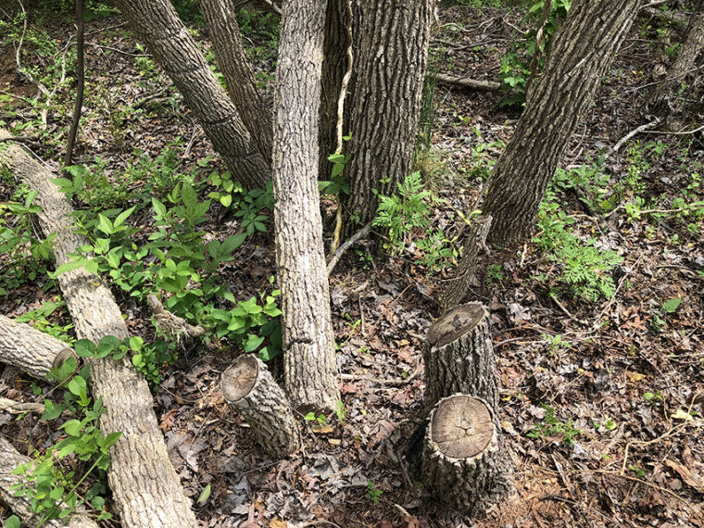
Sweetgum trees clone themselves by sending up root sprouts, so a cluster of trees is often clones of one tree. When these stumps were treated with herbicide, they died, but so did the sweetgums within feet just behind them, because they shared a root system. This will not happen with non-cloning species like oaks.
Raise your squirt bottle for a toast
Opening your woods to sunlight is the best way to rapidly increase quality forage and cover while also enhancing mast production, and Craig’s chainsaw approach makes it easy for one person to make a big difference. So, start making your plans now. Draw up your patches on a map, prepare your firebreaks, purchase herbicide and squirt bottles, and start FSI. At the end of the work, we’ll put down our squirt bottles full of Craig Harper’s Cocktail and toast our mutual success with a different kind of cocktail!
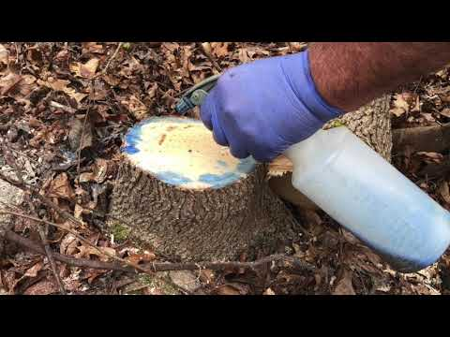
Categories:
Habitat
Tags:
early successional habitat, fsi, timber stand improvement, tsi, young forest
About Lindsay Thomas Jr.:
Lindsay Thomas Jr. is NDA's Chief Communications Officer. He has been a member of the staff since 2003. Prior to that, Lindsay was an editor at a Georgia hunting and fishing news magazine for nine years. Throughout his career as an editor, he has written and published numerous articles on deer management and hunting. He earned his journalism degree at the University of Georgia.

Conclusion
The white paper takeaway from these two articles is that deer habitat in timber can often be improved more quickly by subtraction than by addition. Remove the stems that are monopolizing light and space, release the stems worth keeping, and let the site respond.
That is why the series is effective. Part 1 explains the mindset. Part 2 explains how to operationalize it with simple tools, practical teamwork, and selective herbicide techniques. Together, they provide a field-ready philosophy for improving deer habitat in existing forests.

Source Notes
- National Deer Association. Deer Habitat in a Squirt Bottle part 1: Add Great Deer Habitat by Subtracting. Jan. 20, 2021.
- National Deer Association. Deer Habitat in a Squirt Bottle part 2: Tools, Teams and Techniques. Jan. 27, 2021.
- Mississippi Department of Wildlife, Fisheries, and Parks. How to Kill Trees for Wildlife: The Hack-and-Squirt Method.
- Ohio State University Extension, Ohioline. Controlling Undesirable Trees, Shrubs, and Vines in Your Woodland.

